Pimpri Chinchwad Education Trust’s

Pimpri Chinchwad College of Engineering

Sector No. 26, Pradhikaran, Nigdi, Pune 411044
An Autonomous Institute Approved By AICTE and Affiliated To SPPU, Pune

DEPARTMENT OF INFORMATION TECHNOLOGY

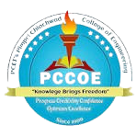

Artificial Intelligence and Machine Learning
Formative Assessment 1
of
T. Y. B. Tech
Academic Year: 2025-26
Semester - I

Cosmetics and skincare recommendation system Using Machine Learning

Guided By:
Dr. Gulbakshi Dharmale

Presented by-
Parth Jadhav 123B1F034
Shruti Jadhav 123B1F035
Divya Kathane 123B1F042

1. Abstract
The skincare and cosmetics market has expanded rapidly, providing a wide variety of products with complex compositions. However, choosing the right product for an individual’s unique skin type remains a challenge. Incorrect selections can lead to unsatisfactory or even harmful outcomes.
This project proposes a Personalized Skincare and Cosmetics Recommendation System that leverages machine learning techniques to suggest suitable products for each user. The system uses TF-IDF vectorization to extract product features from text and applies cosine similarity to compare them with user profiles. A Random Forest classifier validates the recommendations, achieving an accuracy of 99.09%.
The proposed approach helps users make informed product choices, enhances satisfaction, and encourages healthy skincare habits. It can also be integrated into e-commerce platforms for real-world application.

2. Introduction
With the beauty industry booming, consumers face difficulties selecting skincare and cosmetic products suited to their needs. The complexity of ingredient lists and variations in skin type make manual selection unreliable.
This project addresses these challenges using machine learning and natural language processing (NLP) to develop a system that automatically recommends suitable products. By analyzing both product data and user preferences, the model generates personalized recommendations that reduce the risk of unsuitable product use.
The system combines content-based filtering with classification-based verification to ensure accuracy and reliability.

3. Problem Statement
The skincare market is overwhelmed with thousands of options, but there is no simple way to determine which products best suit individual skin types.
Challenges include:
- Diverse skin types (oily, dry, combination, sensitive).
- Complex product ingredient compositions.
- Limited labeled data mapping product suitability to users.
- Need for an intuitive, non-technical interface.
Goal:
To design a data-driven, machine learning–based recommendation system that provides personalized product suggestions based on individual user profiles.

4. Objectives
- To collect and preprocess a comprehensive skincare product dataset.
- To use TF-IDF vectorization for text-based feature extraction.
- To calculate cosine similarity between user input and product data.
- To apply Random Forest classification for validation of recommendations.
- To design an intuitive user interface for input and feedback.

5. Literature Survey
A review of recent research reveals that AI and ML techniques are increasingly being applied to personalized skincare solutions.
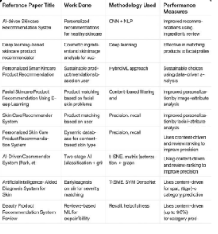

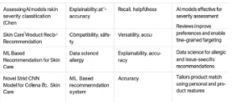

These studies highlight the effectiveness of AI and ML but show limited use of hybrid models combining content-based filtering with classification verification, which this work introduces.

6. Proposed System
The proposed system consists of interconnected modules that work together to provide user-specific recommendations.
System Modules:
- User Input Module: Collects user details (skin type, age, budget, preferences).
- Product Database: Contains ingredients, claimed effects, suitability, and price data.
- Feature Extraction (TF-IDF): Converts text data into numerical vectors.
- Recommendation Engine: Computes cosine similarity between user profile and product data.
- Classification Module: Uses Random Forest to verify product relevance.
- Feedback Module: Incorporates user feedback for continuous learning.
- Output Module: Displays ranked, relevant product suggestions.

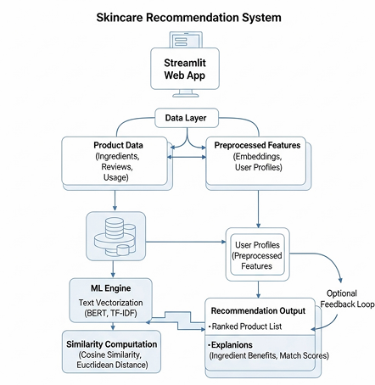
7. Architecture Diagram

8. Methodology
- Data Collection & Preprocessing
  - Gather data of 2500+ products including ingredients, effects, and skin type suitability.
  - Handle missing data, remove punctuation, lowercase, and tokenize text.
- Feature Extraction
  - Apply TF-IDF to represent text numerically, emphasizing distinctive terms.
- User Profile Vectorization
  - Convert user input into the same vector space for direct comparison.
- Similarity Calculation
  - Use cosine similarity to find the most relevant products.
- Classification (Random Forest)
  - Verify top matches through supervised classification.
- Feedback Integration
  - Update the model using real user feedback for continuous improvement.

9. Results and Analysis
- Dataset: 500 sample skincare products tested.
- Random Forest Accuracy: 99.09% in identifying correct product suitability.
- Cosine Similarity: Ensured precise ranking based on ingredient-effect relevance.
- Comparison: Outperformed basic keyword and collaborative filtering models.
- User Feedback: Enhanced over time through adaptive learning.

10. Conclusion
The system successfully provides personalized skincare and cosmetics recommendations by combining TF-IDF, cosine similarity, and Random Forest classification.
It demonstrates that machine learning can effectively handle complex skincare data and user profiles, ensuring satisfaction and safe usage.
Future improvements may involve:
- Incorporating deep learning for better semantic understanding.
- Integrating image-based skin analysis using CNN.
- Extending the dataset with real-time feedback and IoT integration.

11. References
- Park, J., Kim, S., & Lee, H. (2021). AI-driven Skincare Recommendation System. IEEE International Conference on Consumer Electronics (ICCE). IEEE Xplore
- Li, Y., & Zhang, W. (2022). Hybrid Recommendation for Cosmetics E-commerce. Springer International Conference on E-Business and Applications. SpringerLink
- Singh, A., Verma, R., & Gupta, P. (2022). Machine Learning for Skin Disease Detection. Journal of Dermatological Science, Elsevier. ScienceDirect
- Chen, L. (2023). Consumer Preference Analysis in Cosmetics. Proceedings of the ACM Conference on Recommender Systems. ACM Digital Library
- Aggarwal, C. C. (2016). Recommender Systems: The Textbook. Springer.
- Manning, C., Raghavan, P., & Schütze, H. (2008). Introduction to Information Retrieval. Cambridge University Press.
- Scikit-learn Developers. (2025). Scikit-learn: Machine Learning in Python. Scikit-learn Documentation
- Streamlit Team. (2025). Streamlit Documentation: Build Data Apps in Python. Streamlit Docs

